**Python in the frame of DevOps**

For those new to DevOps

DevOps is a methodology that combines development and operations teams to produce software faster and more reliably. It promotes automation, collaboration, and communication between these two teams to increase efficiency and reduce errors.

Now let’s check why Python we used in DevOps

Python is a high-level programming language that is widely used in fields such as web development, data research, and DevOps. Because of its ease of use, readability, and versatility, it is an excellent choice for scripting and automation.

Python offers many benefits to DevOps teams, including simple syntax, an extensive standard library, and a diverse set of third-party libraries and tools. It is a valuable tool for DevOps developers because it can be used for infrastructure automation, configuration management, and provisioning.

**Below are some automation tasks with Python Scripting**

Automation is a critical component of DevOps, and it entails the use of tools and scripts to handle repetitive or time-consuming tasks. This allows DevOps teams to focus on more critical activities such as software development and customer support.

Basic Python Syntax for Scripting

Python scripting is the process of automating processes with Python code. with the help of the following concepts.

1. Variables

2. Functions

3. loops

4. Conditionals

these are examples of basic syntactic elements. These components can be combined to construct scripts capable of performing complex tasks.

**Python coding style and formats**

Code organization is critical for maintainability and scalability. PEP 8 is a Python coding style that provides principles for code formatting, naming, and commenting. To ensure that their code is easy to read and understand, DevOps engineers should use this style.

**Let’s see how to test & Debug Python Scripts**

Debugging and testing are essential processes in Python scripting. Debugging is the process of locating and correcting errors in code, whereas testing ensures that the code works as it should. Python includes tools for debugging and testing, such as the PDB debugger and the unit test module.

**Some libraries in Python for the DevOps task**

Most commonly used python Libraries for DevOps

Python has a large library and module ecosystem that can be utilized for various DevOps tasks. In the following category.

Ansible — Ansible is utilized.

Fabric — Fabric for remote execution. In the below code, we have to establish the connection through SSH. Once that step is done. then we can create a task for example — clone repo, restart the server, and run some tests. Like in below, I am checking the current working directory through the run_pwd task.

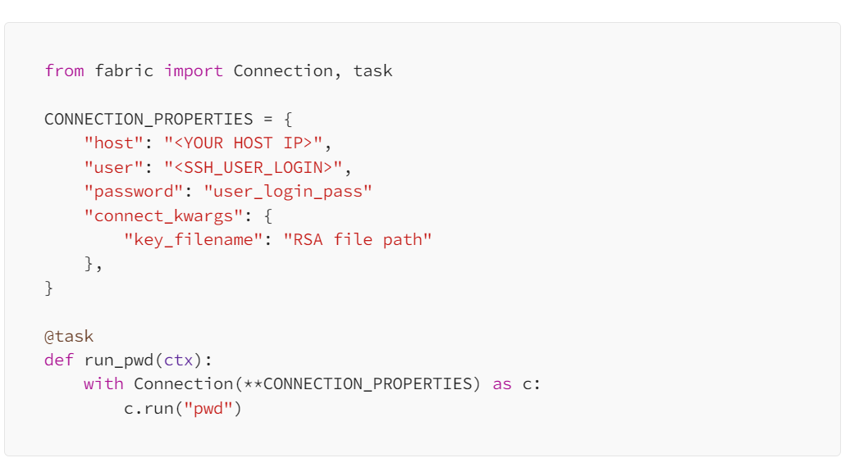

Terraform — TerraformStack for infrastructure provisioning

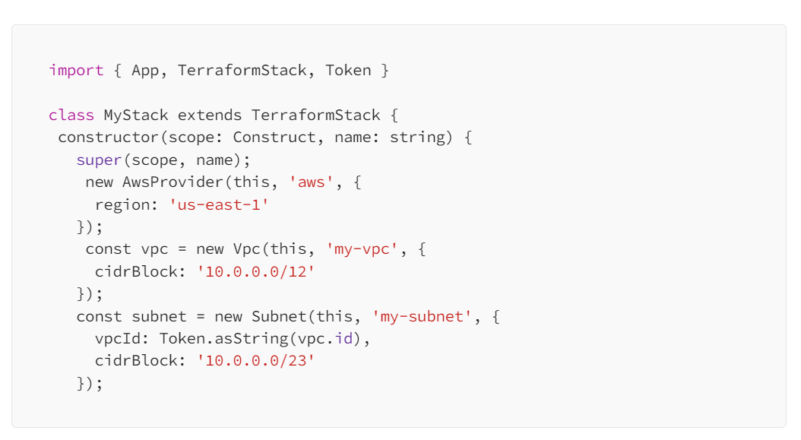

Boto3 — In this Boto3 for AWS automation it provides a Python API for AWS infrastructure services. Using the SDK for Python

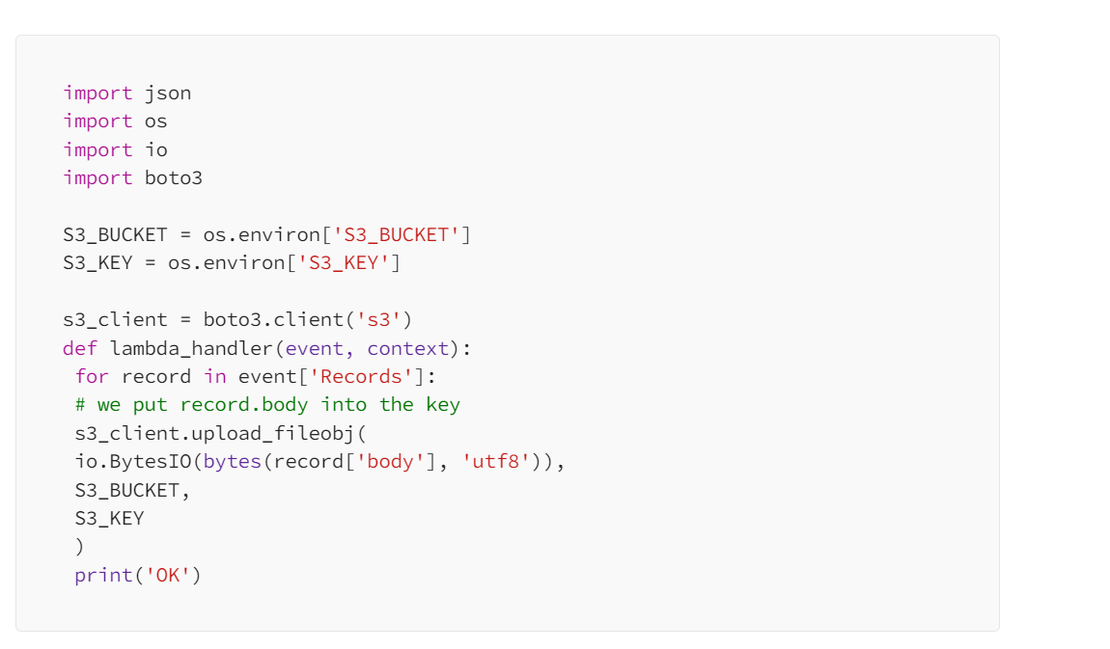

Ansible is a well-known configuration management tool that may be scripted with Python. It defines tasks in YAML files, which may then be executed using the Ansible Python API. Terraform can be used in conjunction with Python to provision infrastructure in a variety of cloud environments.

**4. Managing Infrastructure with Python**

Provisioning Infrastructure with Python

Python may be used to provision infrastructure in a variety of cloud systems, including Amazon Web Services, Microsoft Azure, and Google Cloud. Boto3, PyAzure, and provy libraries allow Python scripts to connect with these cloud providers’ APIs to create and manage infrastructure resources. like below example here I am creating a server with custom user role

